**ECE374 Assignment 6**

Due 03/27/2023

**Group & netid**

*Chen Si chensi3*

*Jie Wang jiew5*

*Shitian Yang sy39*

**Problem 2**

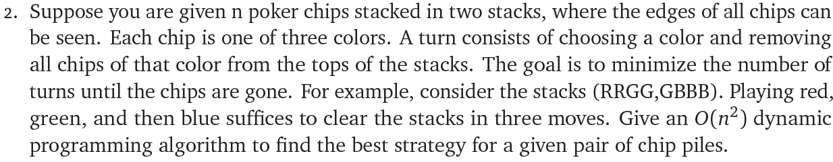

Solution:

Intuition:

(1) Marking the length of two stacks as *a* and *b* respectively, we could construct a (a+1)×(b+1) table with each element T[i, j] represents the minimum number of turns to get the chips gone.

(2) Recurrence Cases

Base Case

When both stacks are gone, we could mark T[0, 0] = 0 as there are no turns needed.

General Case

For the stacks S1 and S2, denote the number of remaining chips after removing all red chips on the top as R1, R2, respectively. Similarly, we could denote the number of remaining chips after removing all blue chips on the top as B1, B2, and the number of remaining chips after removing all green chips on the top as G1, G2. Therefore, we could have the following recurrence relation that T[i, j] = 1 + min (T[R1, R2], T[B1, B2], T[G1, G2]), representing that the minimum number of turns at [i, j] is 1 turn of removal plus the minimal number of turns to remove the rest chips.

(3) Therefore, we have the recurrence function as

$$T\left[i,j\right]=\left\{\begin{aligned}0, i=0 and j=0 \\ 1+\min\left\{\begin{aligned}T[R1, R2] \\ T[G1, G2] \\ T[B1, B2]\end{aligned}\right., otherwise\end{aligned}\right.$$

The final result is in the T[a, b] of the table, which represents the minimum step to “disappear” a stack of a chips and a stack of b chips.

Therefore, the algorithm is:

**BestStrategy**(S1[1…a], S2[1…b]):

T = table(a+1, b+1)

for i 🡨 1 to a:

for j 🡨 1 to b:

if (i==0 && j==0):

T[i, j] = 0 // Base Case T[0,0]=0

else:

T[i, j] = inf

R1, R2 = **NumRemain**(S1, S2, Red)

G1, G2 = **NumRemain**(S1, S2, Green)

B1, B2 = **NumRemain**(S1, S2, Blue)

T[i, j] = 1 + min(T[R1, R2], T[G1, G2], T[B1, B2])

return T[a,b]

// Helper function that takes two stacks and one color

// and return the remaining number of chips after removing

// all ‘color’ chips at top

**NumRemain**(S1[1…a], S2[1…b], color):

k1 = 0

while (S1[k1+1] == color) && (k1+1 <= a):

k1 ++

k2 = 0

while (S2[k2+1] == color) && (k2+1 <= b):

k2 ++

return a-k1, b-k2

Since we fill up a (a+1)×(b+1) table, with a and b proportional to the total number of chips n, and that the cost of operation at each element in the table is constant, we have an algorithm of O(ab) = O(n^2).